10.59: a) A distance 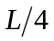 from the end with the clay.
b) In this case 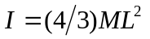 and the gravitational torque is so 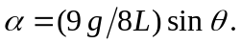
c) In this case 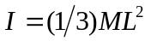 and the gravitational torque is This is greater than in part (b).
d) The greater the angular acceleration of the upper end of the cue, the faster you would have to react to overcome deviations from the vertical.

